Step Functions

What is AWS step functions

Benefits

Create our first AWS step function in AWS console

Go over the basics of building workflows

Test

**What is AWS step function?**

A service that allows us build visual workflow for businesses processes.

Let us add workflow automation, easily and quickly **– with minimal code**

Allows us to create automated workflows with :

1. Error handling built in
2. Parameters passing
3. Security settings (recommended)
4. State management
5. Most of all – very little coding involved if any

For example: check if username and email provided are valid, if so then allow user to open a new account.  
Based on state machines and tasks

In essence:  
 “Automate stuff while integrating other AWS resources.”

**Why AWS Step functions: Motivation and Benefits**

Amazon offers many services we can provision. With those we can integrate and automate the workflows.

**Build and deploy fast**

Use the workflow studio to simply drag-and-drop

Express complex business logic as low code

Event driven workflow

Connects services(aws), systems or peoples quickly

**Write Less Integration code**

Ready to use resources and services available

**Reliable and Scalable**

Used for small projects as well as large

Reliable – has built -in try/catch retry and rollback capabilities for error handling

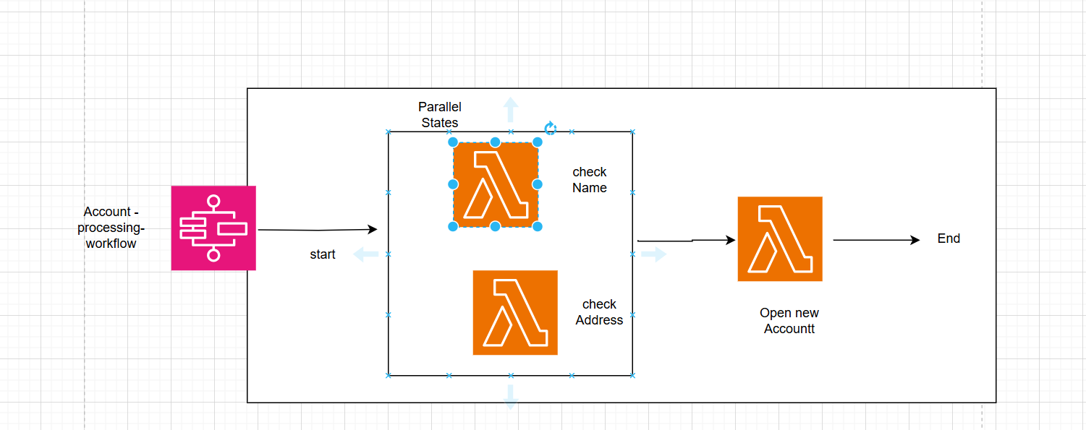

Combine lambda functions with a human approval – use case

Use SNS to notify a human for verification

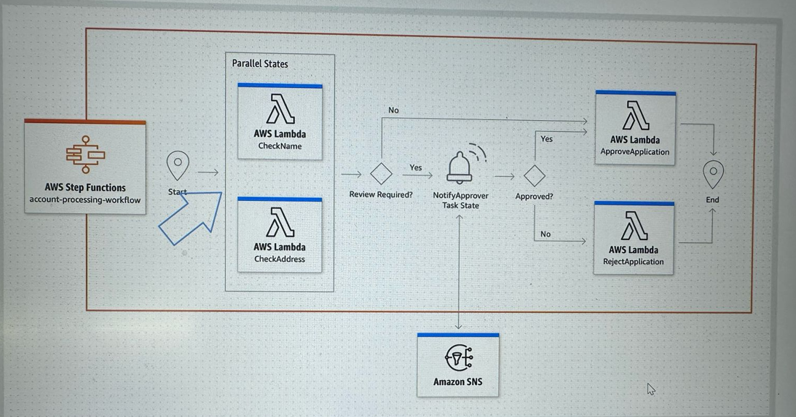

**Building Blocks**

Step functions based on State machines and Tasks (takes input and produces output)

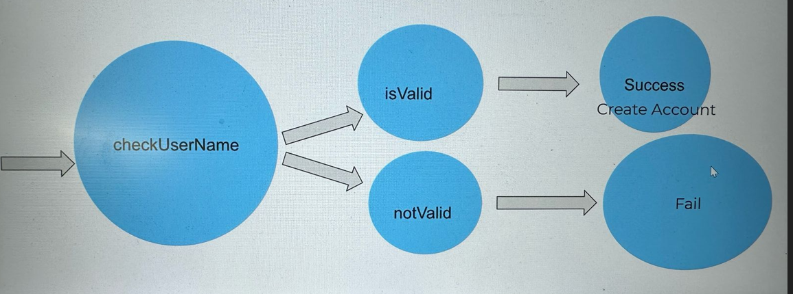

State machine == workflow here.

**Pricing**

Charged based on the number of state transitions required to execute your application

Check official documentation for more details about pricing

4000 state transitions free for free tier

$0.000025 per state transition thereafter

Going in depth we are going to learn:

Dissect a setup function

Go over step functions core concepts  
 State/state types  
 Transitions  
 State Machine Data  
 Input and output processing   
 Executions  
 Error Handling   
 Invoking the step functions from other services

